**1.0 Introduction**

Even though we are in one of the most advanced technological era we still have failed to find a cure for one of the most curious and devastating disease which is known as cancer. Cancer patients go through the worst period of their lives fighting for their lives in the hospital each and every second and breath. Cancer patients undergo a tremendous course of medicine which is very painful to bear.

Due to this condition patients in the hospital should be given special attention at the time of their medication and after so. Mainly the dosage and the concentration and the speed of the medical treatments should be monitored well. Neglection of attention to these patients could end up in taking their lives away from us.

The chemo therapy is given to a set of patients at once by one or two nurses. The concentration of chemo fluid given to each patient differs depending on the stage of the cancer of each patient. Therefore the speed of the chemo fluid at which each patient should be treated differs. For an example those who are in a severe stage of cancer are treated with chemo fluids which are much higher in concentration, and therefore their chemo fluid should be injected to blood in a low speed as the insertion of a higher concentration should not be done in large amounts as it can lead even for death.

So though a set of patients are projected for treatments together at a particular similar time, the time at which they will end up with the chemo fluid injection will vary. And therefore the connection between the canula and the chemo fluid delivery tube of each patient will be needed to remove at different times/ instances. But how it’s managed by nurses currently is that they will pick an average random time and visit the patients and remove the connections of whose treatment has ended. At that time some may have had finished with their treatment for a long time and some may not be having ended up yet. The critical issue is with the patients who had done with the treatment for a long time and waited for a long time for the nurse’s visit to remove the connection. As these patients have stayed for a long time without removing connection, due to the continuation of pressure variance, blood will cause to flow outside of body through the delivery tube. As these patients are cancer patients and are fighting for life at every second, they need to protect what they have at the moment with much more effort, care and attention. If there was a capability to close the connection automatically and ability for nurse to identify each and every patient at the same moment that they become over with the fluid injection, it would be much valuable and much effective.

.0

And also another critical issue is that, some patients try to adjust the speed which was set by the nurse initially at the beginning of the treatment. This happens because of the patient’s unawareness of the fact that even a single drop of fluid can make a huge impact on the health condition even within a millisecond. Though the patients are made aware of the side effects of this kind of misbehavior, they will keep practicing the same neglecting the instructions. So if we were able to introduce a mechanism to detect any speed adjustment done by the patients if any, it will be a great deal in the process.

Another critical issue is that due to the deviations that occur in the internal factors of patient’s body while receiving the treatment, the patient may turn to a critical health condition or else will lead to allergy conditions. But as the nurse is not staying next to the patient always and is having the duty to have a look on each and every patient separately, she will be unable to identify any such critical health condition at the same moment that it begins to happen. And therefore, though it is needed stop the treatment at the rise of any such condition, the patient will be still treated until he/she gets the attention of the nurse. So if we were able to inform nurse about any such critical condition of a particular patient at the same moment that it begins to happen while stopping the fluid injection automatically, it would be much valuable as it helps to protect the patient’s life in an optimum level.

Another issue related to the chemo therapy process is that, the patients need to rest in their beds for minimum of 2 hours from the moment that they finished receiving treatment. But as the patients finish their treatments at different times, the nurse hasn’t got an exact time count of each patient. So she will just think and tell the patients roughly whether to leave or not. So sometimes some patients may not have stayed for 2 hours though they should as it is the period which can happen any intermediate allergy reaction. So if the nurse was able to keep a track on the time spent by each patient after the moment of finishing treatment it would be much easy beneficial for both the patient and nurse.

For this a much needed solution among all the medical treatment units demand to have an organizational and specific treatment device unit which is smart enough to understand medical condition of the patient and inform the detected deformity accordingly.

**2.0 Aims & Objectives**

**2.1 Aims:**

Formation of a digitalized, patients monitoring system where the nurse gets the capability to keep a track on the condition of 0a set of patients with a proper care.

**2.2 Objectives:**

1. The detection of the finishing moment of chemo fluid injection of each patient separately and close the valve across the delivery tube while informing the nurse so as to prevent any blood leakage through the cannula.
2. The detection of any change occurred in the speed of the chemo fluid flow and if found, close the valve across the delivery tube while informing the nurse.
3. The detection of Heart Rate of each patient separately by every 30 seconds starting from the beginning of fluid injection till, the moment of patient leaving the bed. Inform the nurse if any critical variance in heart rate is detected while closing the valve automatically.
4. The display of time count of each patient from the moment of finishing the injection of chemo fluid.

**3.0 System Description**

**3.1 Block Diagram for monitoring one patient**

**A**

**T**

**M**

**E**

**G**

**A**

**32**

Micro Controller in Nurse’s unit

HX 711 Module

Load Cell

LCD display

Heart Rate sensor

Valve

3 LED Bulbs (Red, Blue, Green)

Keypad

Figure 3.1: The Block diagram showing the circuit near patient

**High level Architecture diagram of the circuit near patient**

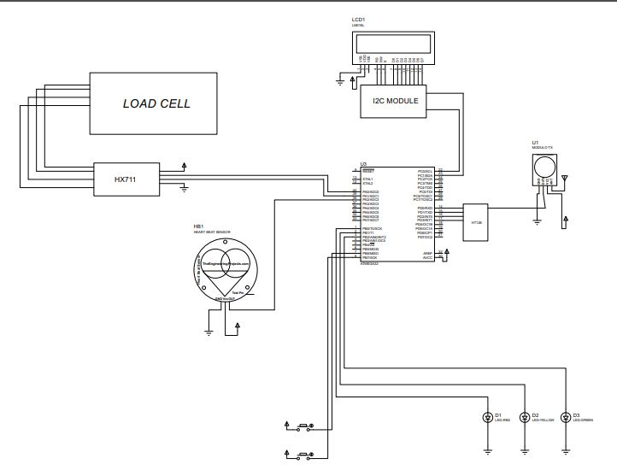

Figure 3.2

**The Setup near Nurse**

**A**

**T**

**M**

**E**

**G**

**A**

**32**

LCD display

.

Push Button (Buzzer stop)

Micro controller in patient’s unit

Buzzer

LED Bulb

Figure 3.3: The block diagram showing the setup near nurse

**High level Architecture of the circuit near Nurse**

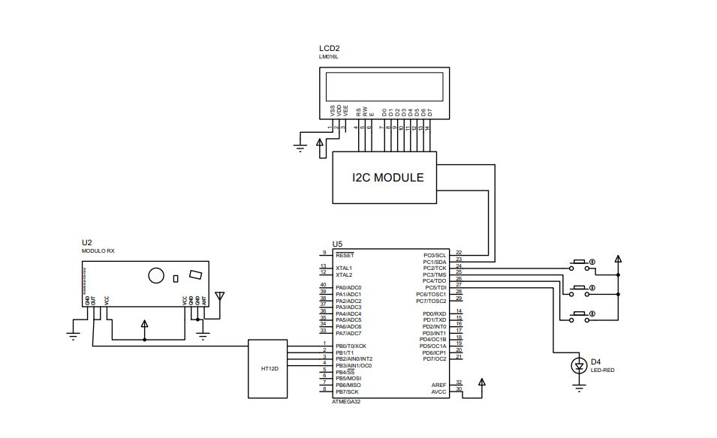

Figure 3.4

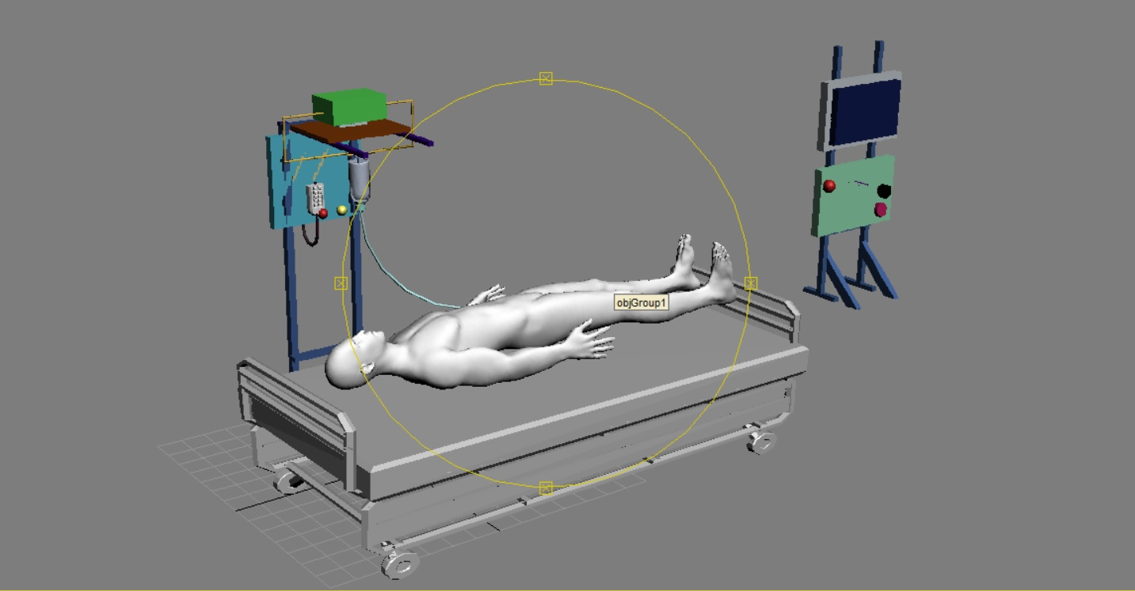**3.2 3D view of the proposed project**

Figure 3.5: General View

**3.3 Description and the final product**

This product idea was based on a research that was done on the chemo therapy given to cancer patients. When a set of cancer patients are given treatment, there are several important conditions that the nurse becomes unable to monitor though they should be addressed with much concern.

1. The inability of nurse to identify any speed adjustment done by patients as they wish.

2. The inability of nurse to find out any critical condition (allergy) that the patient undergoes while having the treatment.

3. The inability of nurse to know about the finishing moment of chemo fluid at a quick second.

4. The inability of nurse to find the resting time spent by each patient from the moment of finishing the therapy.

Our product, the chemo therapy patients’ management system, allows the nurse to have a real time effective detection of each said condition of each patient separately.

This device consists of two main units. Which are the patient unit and the nurse unit.

At the beginning of the treatment, the patient unit will have a heart rate sensor and a fluid control valve and a load cell. This unit will measure the heart rate and the fluid speed of the patient at regular intervals in order to maintain the optimum conditions for treatment. If the variance exceeds the required level the solenoid valve will be automatically closed and the treatment will be stopped.

This sends a message to the nurse unit so that the nurse will be notified that an emergency stop was taken place with the patient’s emergency condition (this could be an abnormal heart rate / a variance in the speed of the fluid flow).

At the end of the treatment, the solenoid valve will be closed automatically and the treatment will be stopped. At the same time a message will be sent to the nurse unit so that the nurse will be notified that the treatment is over. And also the time count starts to run for 2 hours with the detection of the fluid finished moment.

**Final Product**

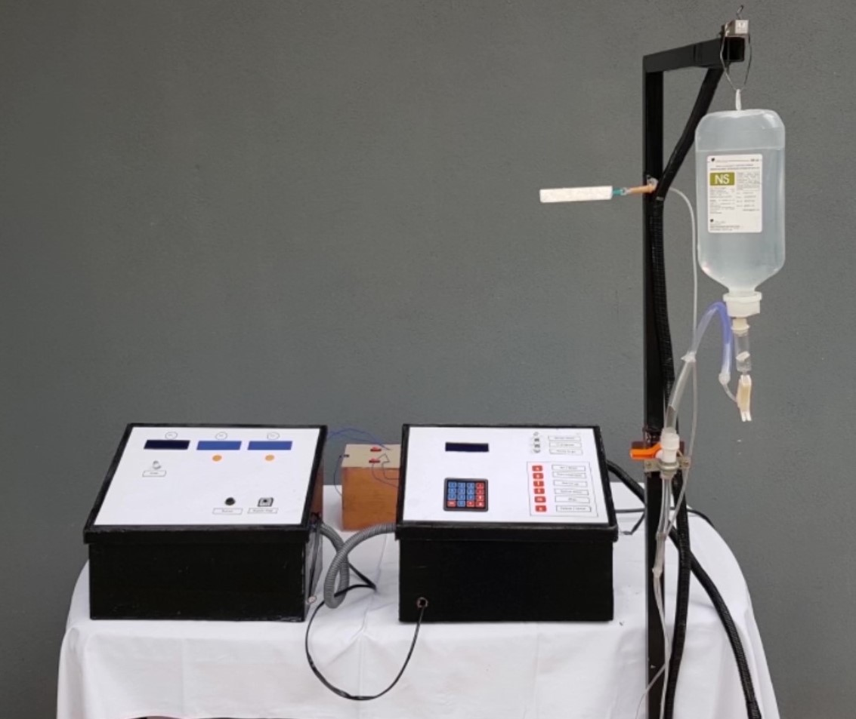

Figure 3.6

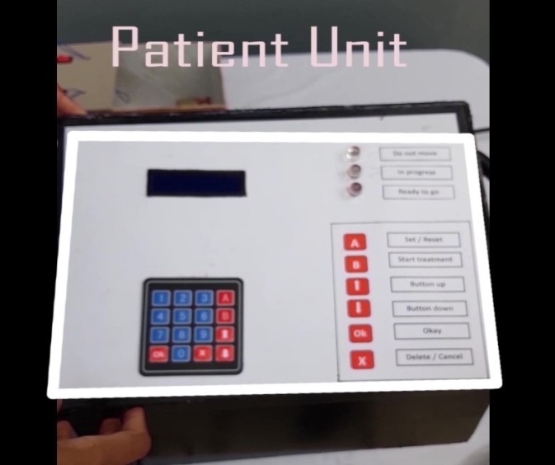

Figure 3.7

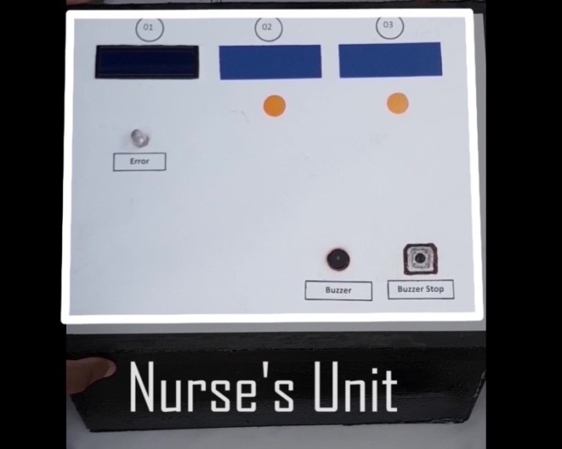

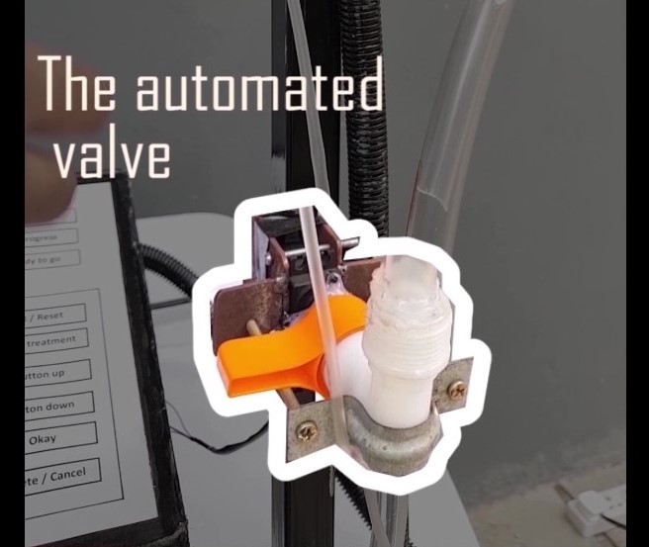 Figure 3.8

Figure 3.9

**4.0 Testing and Implementation**

**4.1 Load Cell**

The load cell measures the weight of the saline bottle from the beginning to the end of chemo fluid injection within equal time intervals. The difference of the weights of first two readings is taken as the initial speed of fluid flow. The difference of the weights of every two consecutive readings is calculated and is compared with the initial weight difference.

If the differences are contrasting, then the message “Speed varied” is displayed on the LCD corresponding to that bed and on the LCD near the nurse’s cubical generating an alarm sound at the same time.

When the weight differences of two consecutive couples of readings are constant, it is detected that the last drop of fluid also has been injected. And then the message “Fluid is over” is displayed on the LCD display near the nurse’s cubical generating an alarm sound at the same time.

**4.2 Heart Rate Sensor**

The heart rate of the patient is measured before starting the chemo therapy and is displayed on the LCD near patient. The heart rate of a healthy person is in between 60-120.After starting the therapy, the heart rate is checked by every 2 minutes and is checked whether available within the favorable range. If it is out of the range, then in that situation the patient is considered as at a critical condition and therefore the message “Critical condition” will be displayed in the corresponding LCD near nurse’s cubical while ringing the emergency alarm at the nurse’s cubical.

**4.3 Keypad**

A keypad is used to give an external manual input value for the heart rate when it is needed to check the accuracy of the system.

And also to carry out the functions of the system prior to the injection of fluid to the patient.

**4.4 LED Bulbs and Push buttons**

* **Near patient**

There are three LED bulbs and two push buttons near the patient’s bed.

Red - Tells the patient to not to move

Blue - The therapy is in progress

Green - Ready to go

Reset Button - Clear the previous patient’s data

Start Button - Setup the circuit for the new patient

When the therapy is to be started and when the last drop of fluid also has been injected, the patient is said to lie on the bed without moving. And that message is displayed on the LCD placed there and by lighting up the Red bulb

When the therapy is on progress that status is displayed on LCD while having the blue bulb lighted up.

When the patient has stayed for 2 hours after the therapy, the green colour bulb lights up and the message “Ready to go” will be displayed on the LCD there.

* **Near Nurse’s cubical**

There are push buttons, one LED bulb and a buzzer

LED Bulb - The LED bulb near the LCD corresponding to the patient’s bed number will light up when any nurse’s attention needed condition is detected.

Buzzer - Rings an alarm at any such detection

Buzzer stop button - Stop the buzzer alarm (by nurse) when known about the detection

**4.5 Solenoid Valve**

The solenoid valve was used to block and stop the flow of chemo fluid to the patient and stop the treatment automatically when the detection of any critical situation is found.

**4.5** **Amendments**

* Heart rate Sensor - As alternative to the blood Pressure Sensor

As the Blood pressure sensor is much expensive, we thought of replacing it by the heart rate sensor.

Under that we decided to figure out any critical conditions that could happen to the patient while receiving the treatment and after

* Wired Connection - As alternative to the RF Module

As there isn’t a long distance from patient to nurse’s cubical, and also as there is a probability for the data given to the RF transmitter to get mixed up and get varied from the exact value when reaching the nurse’s cubical, we decided to remove the RF module and move for a wired connection between the nurse unit and the patient’s unit as it accomplishes our need in a more accurate and effective manner.

**4.6 References**

<https://www.electronicwings.com/avr-atmega/atmega1632-adc>

<https://www.brainy-bits.com/load-cell-and-hx711-with-arduino/>

<https://www.electronicwings.com/avr-atmega/atmega1632-i2c>

<https://electrosome.com/push-button-switch-atmega32-microcontroller-atmel-studio/>

<https://learn.sparkfun.com/tutorials/getting-started-with-load-cells/all>

<https://www.electronicwings.com/avr-atmega/4x4-keypad-interfacing-with-atmega1632>

<https://www.electronicwings.com/components/lcd-16x2-display-module>

**4.7 Programming parts of the project**

**5.0 Appendix**

Individual Contribution

1. **Student name - M.D.N Chandrasiri**

As the leader of the group I planned the structure of the algorithm as well as the structure of the hardware components and how it should be properly aligned along with the software and distribute the work needed to be done among the members.

I mainly researched on the Atmega 32 microchip programming and how the sensors and actuators being integrated with it.

Since the project required a input from the user I found out that the most efficient way to do it was by having a keypad. Using a 4x4 Keypad was the optimum solution. By using the keypad, we can input numerical inputs such as a manual heart rate input when needed and we can use the keypad to give selection commands as well (such as set/reset/back).

In this system we need to communicate between nurse unit and the patient unit. For this the options that were via zigbee module or RF module wireless transmission and wired transmission. Though both these units are stable and fixed I decided to use wired transmission since it’s much accurate and efficient in data transmission.

I had to synchronize clock of both microchips to 8MHz and then do the wired data transmission. By this in an emergency situation we can send emergency measure and notify the nurse via the nurse unit display.

This Is done through UART serial communication transfer protocol. I used RX,TX ports in order to do this in both microchips.

1. **Student name - Arulanandam S.R.C**

I did research about the basic medication methods that are taken place in the medical sector and the most practical physical structure and solution and they were suggested by me for implementation.

A main issue we had to solve was to control the medical fluid that is been transmitted to the patient. For this best solution was to put a Valve that could be controlled with a control signal. The valves that were in the market were the solenoid valve and the air pump valve. Since the solenoid valve requires an initial pressure to the fluid to flow it was not suitable because the fluid will only give a free flow pressure. When it comes to air pump it was not suitable for use because it doesn’t completely close when the power is not given. But it gives a pressure at power state. For this I used a servo motor and align it with a normal tap head. When the servo motor signal is been given the head of tap will rotate and work as a valve. This is was the perfect solution because it doesn’t require an initial pressure as well.

There were problems with adjusting the fluid line and aligning it with the pump input and output lines because of the diameter difference between the saline line and pump ports. For this I used multiple diameter rubber tubes which will be connected together and connect the large diameter tube with the small diameter tube.

From the nurse control unit the flow could be controlled by receiving a input a signal. For this I put a pushbutton which can produce a interrupt signal. In an emergency a buzzer is implemented to notify. This is controlled by a controlled signal. To stop the emergency buzzer also a push button is integrated.

I learned pcb designing and how to design It using pcb wizard software. This is was a challenging progress at times cause all the paths shouldn’t cross each other and for each sensor and actuators ground and VCC should be supplied from a common place. After designing this I printed it on a photo paper cause when the ink is printed on the photo paper it will make a better print and stick on the copper board in a better way.

I contributed In making the power supply. I designed the circuit using diodes and regulators. We use a 7805 in order to get a 5v output. At sometimes we had problem with the capacitor because we used a smaller voltage capacitor by mistake. Then I decided to put 50, 1000microfarade capacitor which was successful.

1. **Student name - Bharathi T.P.G.N.M**

I researched about the allergy reactions that a patient could undergo while receiving the chemo therapy and after the chemo therapy. It was found that while receiving the treatment the patients can undergo immediate allergy reactions and after the first two hours of finishing treatment, the patient can undergo an intermediate allergy reaction. So I researched about the condition of a patient when in treatment situation and about the optimum heart rate they should maintain. Usually a healthy treatment is between 60-130 beats per minute. Having a heart rate out of this range could be because of an allergy situation or another medical defect which makes the patient not suitable for medication.

I researched about the heart rate sensors available in the market nowadays. In the market there are many sensors we could find and they were the electrical heart rate monitors and the optical heart rate monitors. Out of them I decided to use the optical heart rate monitors as they are easily wearable for the patient and are also quick to setup to a patient when giving the therapy to a set of patients. I worked on the procedure that the nurse should be informed when any error is detected in the patient as low heart rate or high heart rate.

I contributed in structural designing especially with the patient unit since a patient should be aware whether he or she is supposed to move or not, and whether the medication is in progress.I decided to put 3 LED indicating whether not to move and indicating whether the medication is in progress and ready to go.

1. **Student name - Prasadini W.A.R**

I did study and learn about the load cell and its calibration. The main intension of adding a load cell was to get the weight variance and check the variance of the fluid speed and also to detect the time of finishing the last drop of chemo fluid under medication. For this we needed a weight measuring device that could get the weight of the medication bottle. Due to this I decided to integrate a load cell and get input.

A main issue I faced when implementing the load cell was the calibration of the load cell. There were load cells which can measure 1kg, 5kg, and 10kg in the market. For this I used a 1kg load cell because the weight we use to measure is the fluid bottles weight and it is less than000 1kg. I took many readings and by putting them in to a (y = mx + c) I was able to calibrate and get a much accurate reading.

By drilling the bar which holds the medication bottle I was able to fix the load cell firmly by using a nut and bolt for a steady reading.

I contributed in structure designing as well. In there, I helped my friends to make the structure of the patient unit and nurse unit. I helped in organizing different components in each unit so as to build up the units in a convenient way.

1. **Student name - Vindula A.P.D**

I did research in interfacing LCD display with the microchip. I did research about the 4 bit mode and 8 bit mode transmission. Afterwards I thought of using the I2C device for data transmission since it is much more efficient and easy to integrate. By this I was able to reduce the number of pins that was used in data transmission to the LCD screen. There were so many bugs that I faced in codes due to so many various reasons.

I learned about PCB designing parts as well. As I found there were two methods to get the circuit printed on the copper board, one method was by using the laser drawing techniques which we can outsource and get printed and the other one was the printing that is done with the ironing machine using the printed pcb on the photo paper. As the ironing method was much cheap and it was also very good at fulfilling need and very flexible I decided to iron it, when I got the photo Paper with the printed PCB circuit I kept in on copper board firmly and ironed it for 8-10 minutes. And we washed the paper material using water. Then it was dried well and bits of missing pieces were drawn again using a permanent marker. And then the copper was removed away using ferric chloride. In the market there were ferric chloride power and well as the liquid we used the liquid since it has the best concentration. But soaking the copper boards in the ferric chloride the copper was removed well. Then it was dried out again and using thinner the blank ink printed marks were removed and copper lines were cleared.